HOBBIES
1.) Spoj názvy s obrázky:
FISHING
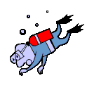
CYCLING
WATCHING TV
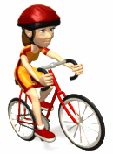
DIVING
TRAVELLING
CHESS

SWIMMING
READING BOOKS
FOOTBALL
SKATING

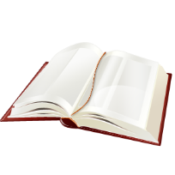
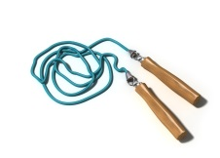
2.) Zjistěte, co čí je a doplňte do vět:
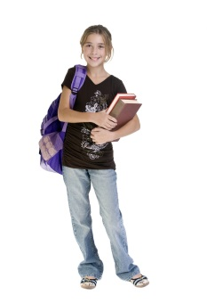
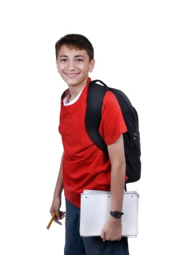

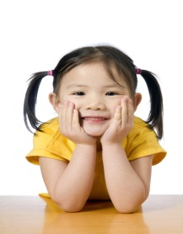
Lucy
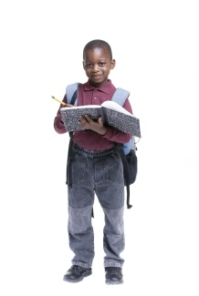
Mike
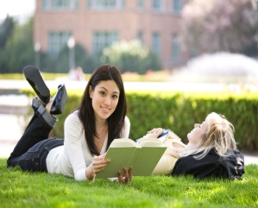
Jane Emily

Margaret George

The book is __________________________ .
The computer is ________________________ .
The skipping rope is ______________________.
The microphone is ______________________.
The boll is ______________________________.
( The balloon is Carol’s. )

3.) Hledej názvy zálib a odděl je barevně:
CYCLINGREADINGFISHINGWATCHINGTVSWIMMING

4.) Doplň slova do textu z nabídky:
FISHING GAMES COLORS LAKES RIDING LETTERS HOBBY
My favourite hobby is ……………………, because I like fish and …………………… . And you, what is your favourite …………………….. . I like ………………….., because my favourite hobby is painting. Do you like horse ……………………. ? No, I like playing PC …………………… . And you John, what is your favourite hobby? I like collecting stamps from ………………………. .

5.) Nakresli – What is your hobby?

