**HOBBIES**

**1.) Spoj názvy s obrázky:**

C:\Users\uživatel\AppData\Local\Microsoft\Windows\Temporary Internet Files\Content.IE5\9MC97RJZ\MC900397438[1].wmf

C:\Users\uživatel\AppData\Local\Microsoft\Windows\Temporary Internet Files\Content.IE5\9MC97RJZ\MC900434599[1].wmf **FISHING**



**CYCLING**

C:\Users\spravce\AppData\Local\Microsoft\Windows\Temporary Internet Files\Content.IE5\JC0Y6NU1\MC900232521[1].wmf **WATCHING TV**

 **DIVING**

C:\Users\uživatel\AppData\Local\Microsoft\Windows\Temporary Internet Files\Content.IE5\9MC97RJZ\MC900358555[1].wmf **TRAVELLING**

C:\Users\uživatel\AppData\Local\Microsoft\Windows\Temporary Internet Files\Content.IE5\R635813G\MC900389134[1].wmf **CHESS**

C:\Users\uživatel\AppData\Local\Microsoft\Windows\Temporary Internet Files\Content.IE5\E4AHRP8A\MC900281339[1].wmf **SWIMMING**

C:\Users\uživatel\AppData\Local\Microsoft\Windows\Temporary Internet Files\Content.IE5\R635813G\MC900446534[1].wmf **READING BOOKS**

C:\Users\uživatel\AppData\Local\Microsoft\Windows\Temporary Internet Files\Content.IE5\E4AHRP8A\MC900428321[1].wmf **FOOTBALL**

**SKATING**

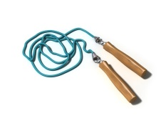**2.) Zjistěte, co čí je a doplňte do vět:**

C:\Program Files (x86)\Microsoft Office\MEDIA\CAGCAT10\j0299763.wmfC:\Users\uživatel\AppData\Local\Microsoft\Windows\Temporary Internet Files\Content.IE5\9MC97RJZ\MC900299853[1].wmf

C:\Users\uživatel\AppData\Local\Microsoft\Windows\Temporary Internet Files\Content.IE5\R635813G\MC900349053[1].wmfC:\Users\uživatel\AppData\Local\Microsoft\Windows\Temporary Internet Files\Content.IE5\E4AHRP8A\MC900019332[1].wmf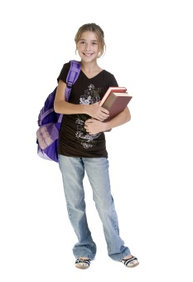

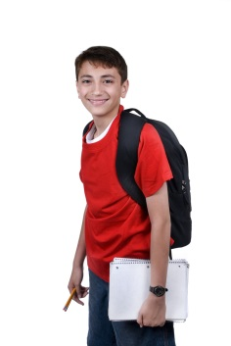

**C:\Users\uživatel\AppData\Local\Microsoft\Windows\Temporary Internet Files\Content.IE5\MOK6FP8R\MC900435743[1].wmf**

 **Lucy**

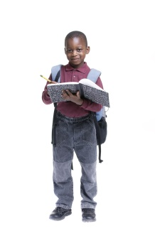 **Mike**

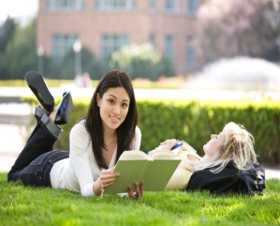 **Jane Emily**

**Margaret George**

The book is __________________________ .

The computer is ________________________ .

The skipping rope is ______________________.

The microphone is ______________________.

The boll is ______________________________.

( The balloon is Carol’s. )

**3.) Hledej názvy zálib a odděl je barevně:**

**CYCLINGREADINGFISHINGWATCHINGTVSWIMMING**

**4.) Doplň slova do textu z nabídky:**

**FISHING GAMES COLORS LAKES RIDING LETTERS HOBBY**

My favourite hobby is ……………………, because I like fish and …………………… . And you, what is your favourite …………………….. . I like ………………….., because my favourite hobby is painting. Do you like horse ……………………. ? No, I like playing PC …………………… . And you John, what is your favourite hobby? I like collecting stamps from ………………………. .

**5.) Nakresli – What is your hobby?**